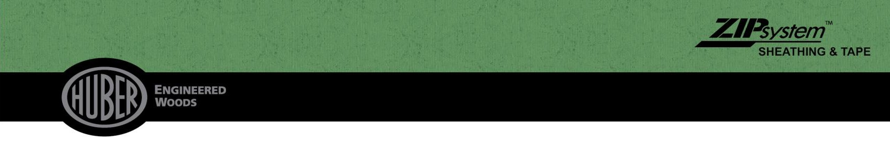

ZIP SYSTEMTM Multi-Purpose Tape

MANUFACTURER
Huber Engineered Woods LLC
10925 David Taylor Drive, Suite 300
Charlotte, NC 28262
800.933.9220 • Technical Service: 800.933.9220 x2716 huberwood.com

BASIC USE AND APPLICATIONS
ZIP System™ multi-purpose tape is a versatile exterior tape suited for various jobsite applications. It, provides durable moisture protection making it ideal to protect deck joists, ensuring the structural members reliable, long-lasting performance.

ZIP System™ multi-purpose tape is a pressure-activated tape featuring weather-resistant technology, making it ideal for a wide range of everyday applications. Engineered for year-round performance, it offers reliability and durability. Ideal for covering the top of deck joists, stringers, it provides protection and adhesion, helping to extend the life of wood structures.

ZIP SystemTM multi-purpose tape has four layered components:
- Versatile tape backer that provides weather resistance
- Bonding layer that permanently joins the acrylic layer to the body of the tape
- Dimensionally stable inner layer that incorporates antioxidants that make ZIP SystemTM multi-purpose tape trusted for performance and durability
- Slip-resistant surface layer

ADVANTAGES
ZIP SystemTM multi-purpose tape is an acrylic tape with a robust and aggressive adhesive. The product’s specially formulated acrylic adhesion forms a powerful bond making it a great versatile option to flash a variety of surfaces. ZIP SystemTM multi-purpose tape also displays excellent elongation, accommodating the normal expansion and contraction found in wood construction and everyday use.

STORAGE AND HANDLING
Store ZIP SystemTM multi-purpose tape in the original packaging at a temperature not to exceed 90 °F (32 °C). Store in clean, dry place. When stored as recommended in its original unopened container the typical shelf life for ZIP SystemTM multi-purpose tape is 24 months from the date of manufacture.



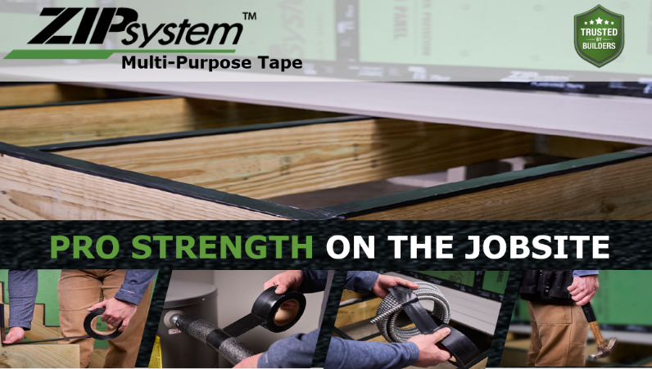

ZIP SystemTM Multi-Purpose Tape
Adhesive Type | Acrylic
Service Temperature | -40° F to 240° F
Installation Temperature Range | 0° F to 120° F
Compatibility | Wood, engineered wood, pressure treated wood, common metals (painted or unpainted) and most plastics.
Tensile Strength | 938 psi
Tape Elongation | 400 – 800%

SIZE
ZIP SystemTM multi-purpose tape is available in the following widths:
- 2-inch (50.8 mm) by 75-ft (22.8 m)

TAPE INSTALLATION
ZIP SystemTM multi-purpose tape is a pressure sensitive tape that requires force to properly adhere to the substrate. When installing onto deck joists, apply ZIP SystemTM multi-purpose tape and apply firm pressure. Refer to the installation instructions below for detailed information and illustrations of ZIP SystemTM multi-purpose tape.

AVAILABILITY
Huber Engineered Wood’s ZIP SystemTM multi-purpose tape is available nationwide. Visit Huberwood.com or contact Huber Engineered Woods for a retailer near you.

ZIP SYSTEMTM MULTI-PURPOSE TAPE INSTALLATION – DECK JOISTS

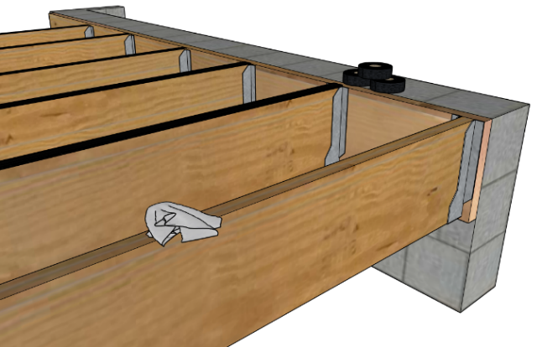

Step 1: Prepare the Surface
Ensure the substrate or deck joists are clean, dry, and free of dirt or debris. Make any necessary repairs to the surface before applying the tape.

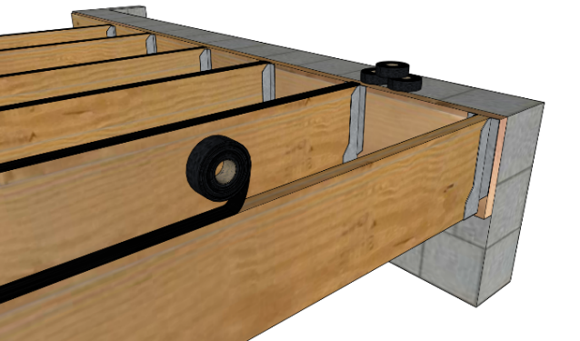

Step 2: Measure and Apply the Tape
Measure the length needed and cut the ZIP System™ multi-purpose tape to size using a utility knife or scissors. Align the tape over the area to be flashed or covered, ensuring it is centered on the surface.

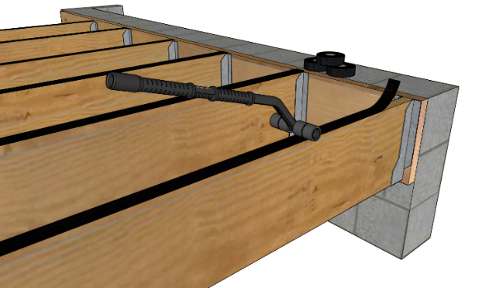

Step 3: Apply Pressure to the Tape
Apply consistent pressure to ensure the tape fully adheres to the substrate and achieves maximum adhesion. Rolling the ZIP SystemTM multi-purpose tape firmly with a rubber-faced roller will significantly reduce the chance of wrinkles or “fish mouths” (large wrinkles that are avenues for water to get into the seam) from forming. If wrinkles or fish mouths occur, remove that section of tape, replace it with a new piece, then overlap the existing tape by at least 3 inches.

TECHNICAL SERVICE
Please visit ZIPSystem.com or call 800.933.9220 x2716 to speak to a technical representative.

WARRANTY
ZIP System ™ multipurpose tape carries a limited warranty. Limitations and restrictions apply. View the ZIP System multi-purpose tape warranty at https://www.huberwood.com /blog/warranties for details.

PRODUCT LIMITATIONS

ZIP System™ multi-purpose tape may not be used in the following applications: sealing panel seams on ZIP System sheathing or any other panel product, flashing window flanges or sill pans (doors or windows), or other construction flashing.

© 2025 Huber Engineered Woods LLC. ZIP System, AdvanTech, X-Factor, AdvanTech X-Factor, EXACOR and the accompanying ZIP System, AdvanTech, X-Factor, AdvanTech X-Factor, and EXACOR logos and design are trademarks of Huber Engineered Woods LLC. Huber is a trademark of J.M. Huber Corporation. Third-party products and trademarks are trademarks of their respective owners. Limitations and restrictions apply-- visit Huberwood.com for details. HUB-9250 REV 12/01/2025

